**Name:** Deepak Sadh

**Roll Number:** 19k0353

**Submission Date:** 19/02/2023

**Home**

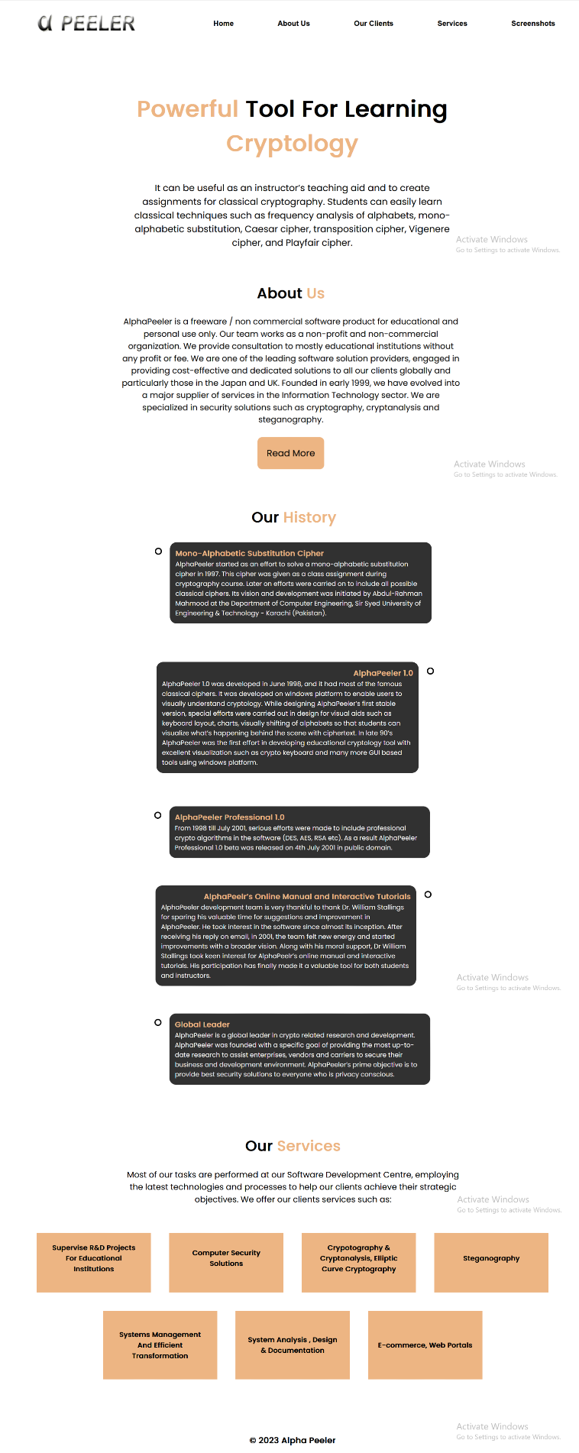

**About Us**

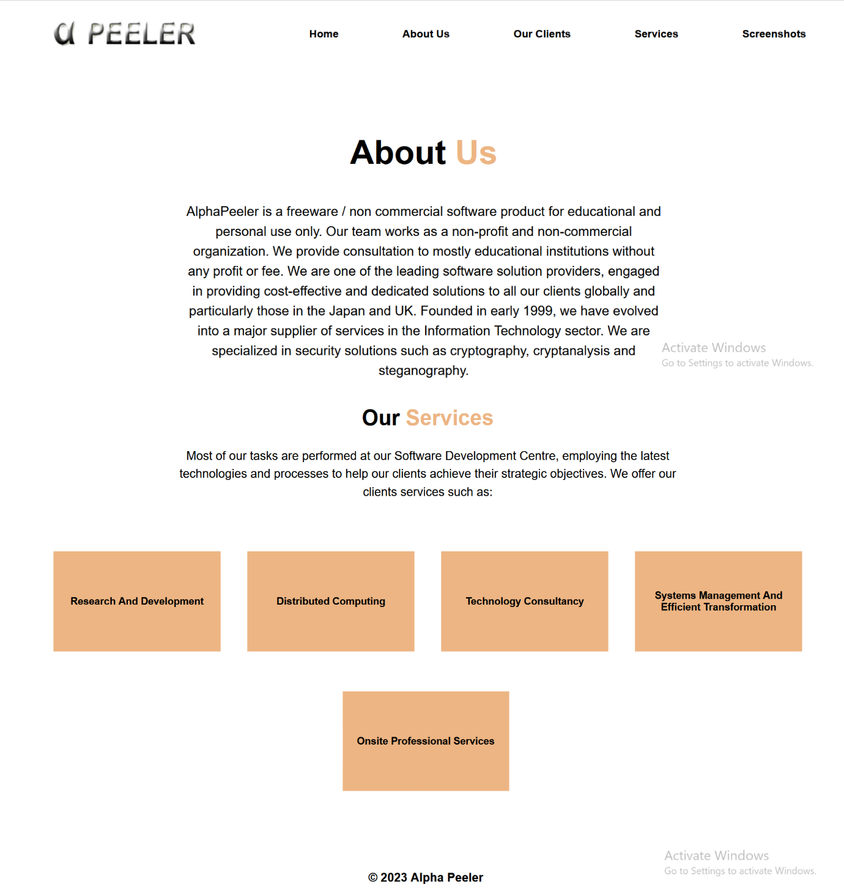

**Our Clients**

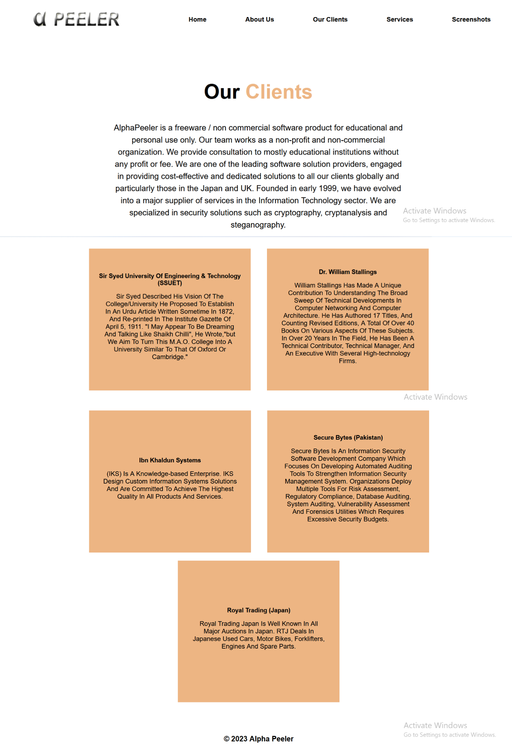

**Services**

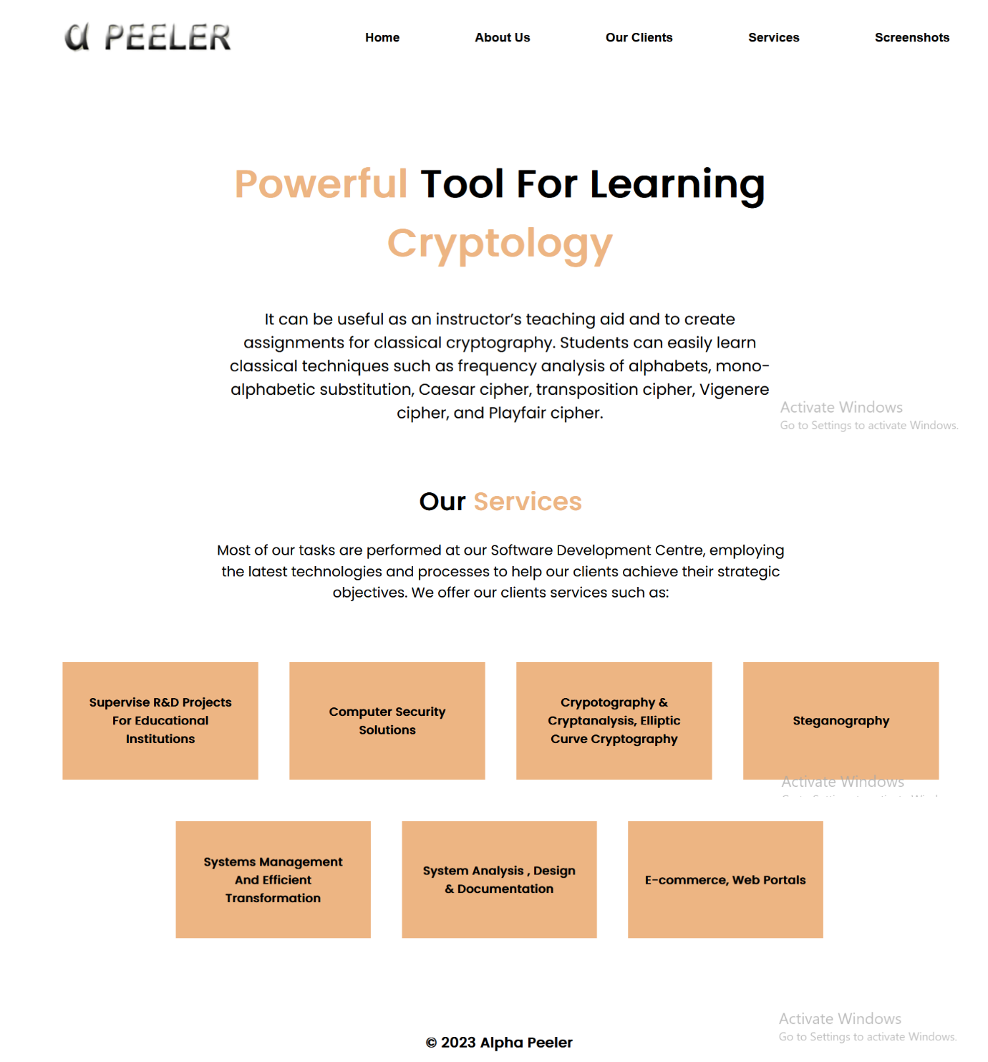

**Screenshots**

